Currently Big Mountain Resort is priced at $81.00 for a single ticket based on market values for the resorts in the state of Montana. My recommendations for Big Mountain Resort is for them to price their tickets at $95.87 based on the model ran in our analysis of the data provided. This recommendation comes from our finding that Big Mountain Resort performs at the top of modeled important features across the country as shown below.

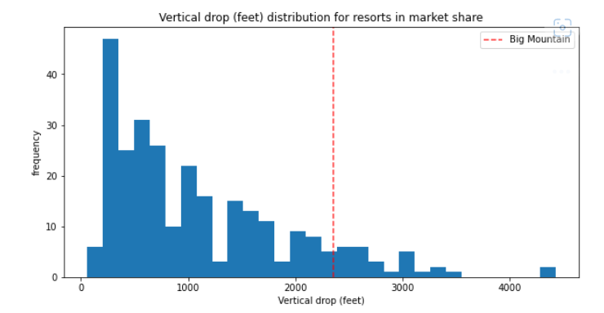 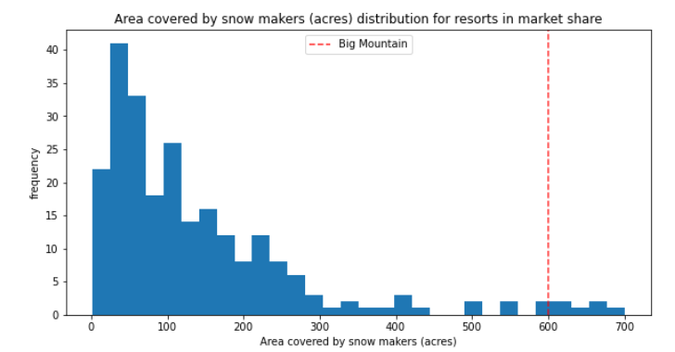

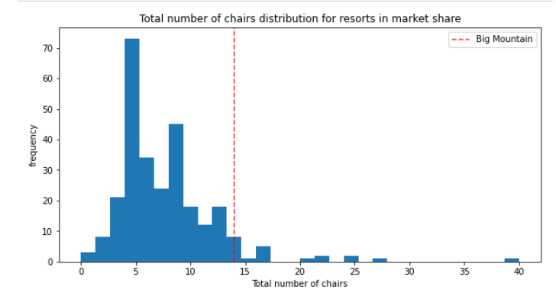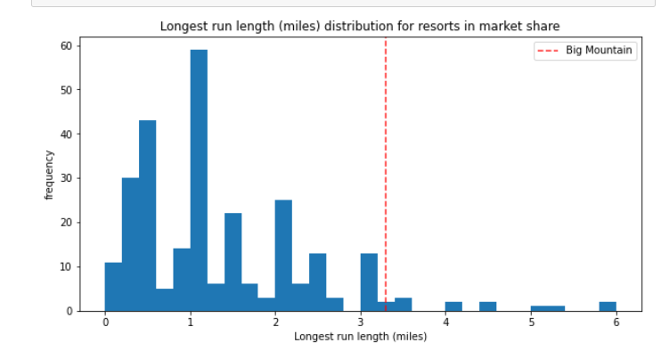

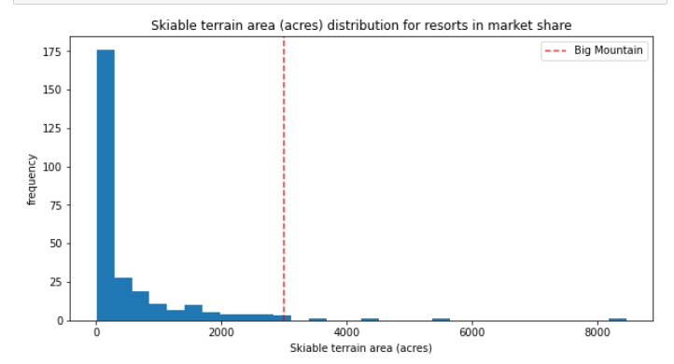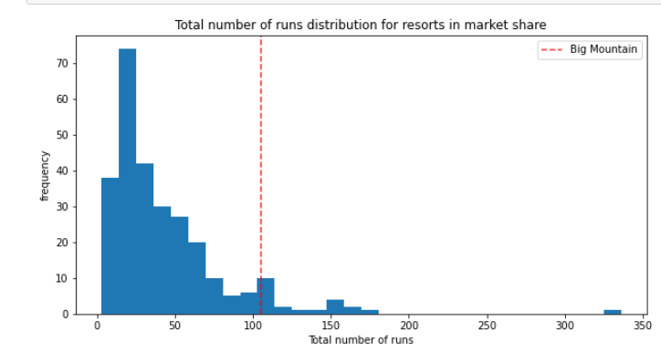

I would also recommend that Big Mountain resort allocate resources into increasing their vertical drop by 150 feet, installing an additional chair lift, and adding 2 acres of snow making. This is supported by the models prediction that these 3 features combined supports a $9.90 increase in price which amounts to an estimated revenue increase of $17,322,717. I do not strongly recommend closing runs at this time as we lack information of the operating costs of those runs. Additionally, closing runs is associated with a decrease in ticket price value as shown by the figure below.

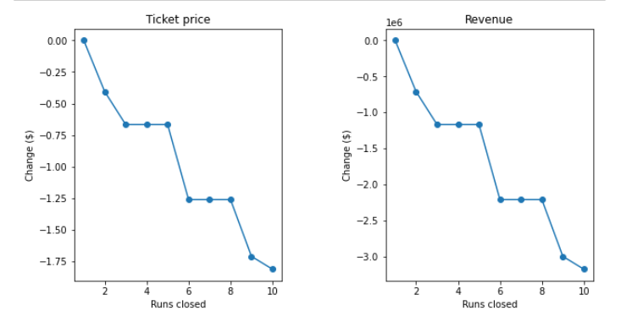

For the businesses proposal of adding .2 miles to their longest run, there was no increase predicted by our model so I am unable to recommend that feature at this time.